AIX1 / DOC1 issue

*Brandon Potter*

When you start seeing these:

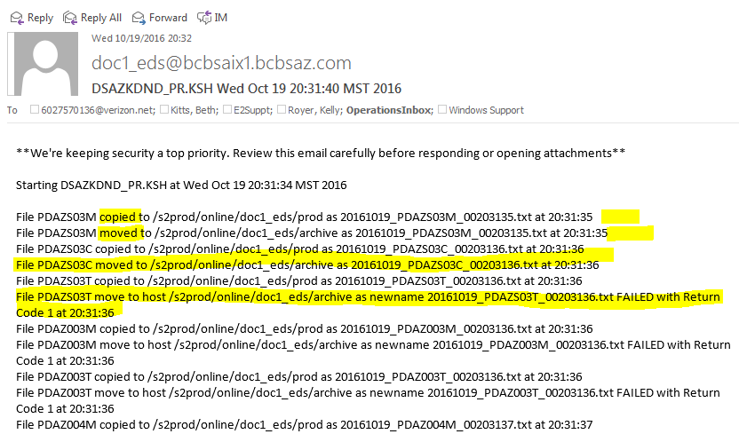

*Notice the top 2 lines don’t say “FAILED” at the end.*

Means /doc1_data on AIX1 (bcbsaix1.bcbsaz.com / 198.133.186.2) is full. You can check by running “df” while logged into AIX1. NOTE: You will need PuTTY and root access. Ask Rob Hall or Brandon Potter for the password. I’m not writing in place text. These errors only affect archive abilities because it can still copy to the correct destination for Active Batch. **THIS ISN’T CONFIRMED TO NOT AFFECT PRODUCTION AT A LATER TIME!!!**

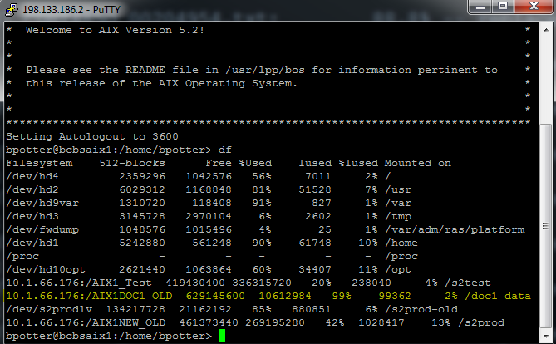

*See highlighted*

Easiest fix: start compressing files older than 90 days. This can be done with:

root@bcbsaix1:/doc1_data> find . –type d ! –name ‘.’ –prune –o \( -mtime -<Oldest> -a –mtime +<newest> \) –exec gzip -9 –v {} \;

**Explanation:**

The *find* command recursively crawls a directory and every subdirectory for files that match conditions. While in /doc1_data (achieved by “*cd /doc1_data*”), the “.” means current directory. The first section *-type d ! –name “.” –prune* is preventing *find* from going down subdirectories. The 20% of work for 80% of glory isn’t there. In English:

If current file is a directory and the name is **not** “.”, don’t traverse it.

The “-o” means *or*. So if that first part doesn’t become true, the second part, *\( -mtime -<oldest> -a –mtime +<newest> \) –exec gzip -9 –v {} \;*  runs. Short breakdown:

If the current file is *modified* *before oldest* **and** *modified after newest*, *execute* the command *gzip* with options *-9 –v* on that file.

This will get a range of files and compress them. *gzip* will compress the file and remove the uncompressed file. It won’t group anything together, will add the suffix *.gz* to it, and skip anything already compressed. If you’re uncomfortable with that command (and you should be because you’re affecting production data with root access. ALWAYS WORRY LOGGED IN AS ROOT!), you can change *\( -mtime -<oldest> -a –mtime +<newest> \)* with *–mtime <days ago>.* This will only compress files some days ago.

**If you’re not comfortable running these commands or don’t understand them, please contact Robert Hall or Brandon Potter by cell. My cell is listed in the Ops Contact list in our Sharepoint/Doc1 thing (G:/Ops/Website/index.html).**